# Breast Cancer Classification

Breast cancer (BC) is one of the most common cancers among women worldwide, representing most new cancer cases and cancer-related deaths according to global statistics, making it a significant public health problem in today’s society.

**Objective**The early diagnosis of BC can improve the prognosis and chance of survival significantly, as it can promote timely clinical treatment to patients. Further accurate classification of benign tumors can prevent patients undergoing unnecessary treatments. Thus, the correct diagnosis of BC and classification of patients into malignant or benign groups is the subject of much research. Because of its unique advantages in critical features detection from complex BC datasets, machine learning (ML) is widely recognized as the methodology of choice in BC pattern classification and forecast modelling.

**The Data :** UCI Machine Learning Repository for BC [dataset](http://archive.ics.uci.edu/ml/datasets/breast+cancer+wisconsin+%28diagnostic%29)The dataset used in this story is publicly available and was created by Dr. William H. Wolberg, physician at the University of Wisconsin Hospital at Madison, Wisconsin, USA. To create the dataset Dr. Wolberg used fluid samples, taken from patients with solid breast masses and an easy-to-use graphical computer program called Xcyt, which is capable of perform the analysis of cytological features based on a digital scan. The program uses a curve-fitting algorithm, to compute ten features from each one of the cells in the sample, then it calculates the mean value, extreme value and standard error of each feature for the image, returning a 30 real-valuated vector

## **Data Wrangling**

We conduct the following steps to clean up data and pick useful features.

1. Search for missing values:

* **Unnamed: 32** feature includes NaN, so we do not need it.

1. Drop duplicates:

* Didn’t find any duplicates.

1. **Diagnosis** is our class label.
2. There is an **id** that can not be used for analysis and we drop it.
3. Because differences between values of features are very high to observe on plot (like the **area_mean** feature's max value is 2500 and **smoothness_mean** features' max 0.16340.), so we need **standardisation before visualization, feature selection or classification.**

At this point, we do not have any idea about other feature names.

## **Data Exploration**

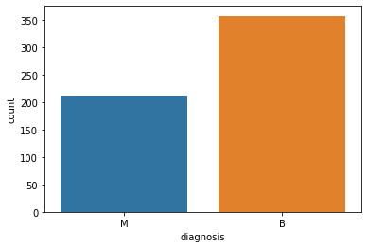

 In Box Plot, we plot features in 3 group and each group includes 10 features to observe better.

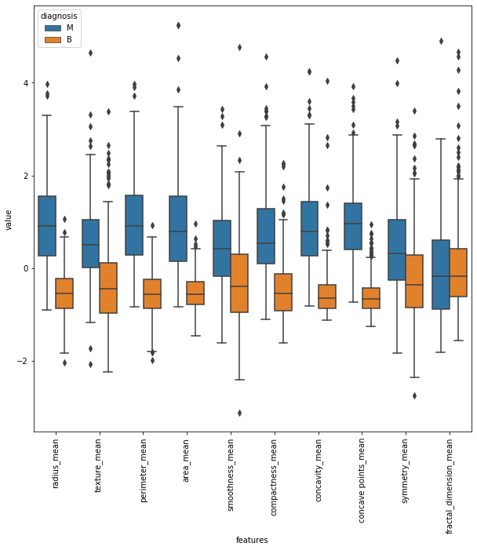

in **texture_mean** feature, median of the Malignant and Benign looks like separated so it can be good for classification. However, in **fractal_dimension_mean** feature, median of the Malignant and Benign does not looks like separated so it does not give good information for classification.

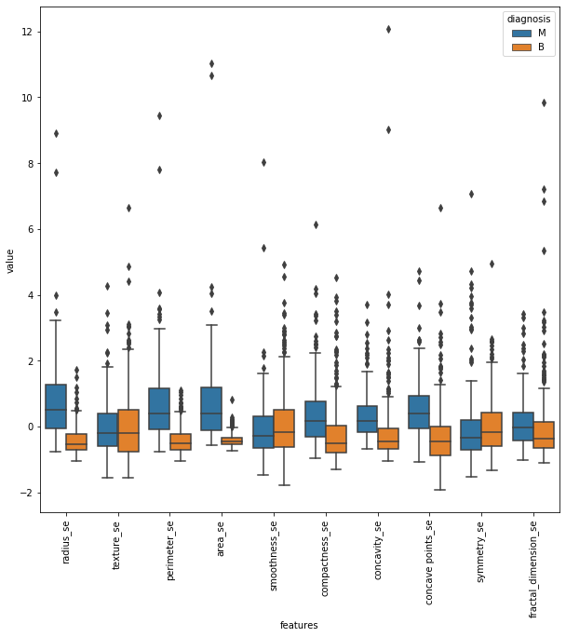

in **concave points_se and concavity_se** features, median of the Malignant and Benign looks like separated so it can be good for classification. However, in **texture_se** feature, median of the Malignant and Benign does not looks like separated so it does not give good information for classification. Also looks like there is correlation between **concavity_worst and concave point_worst.**

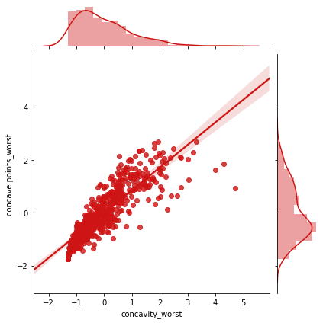

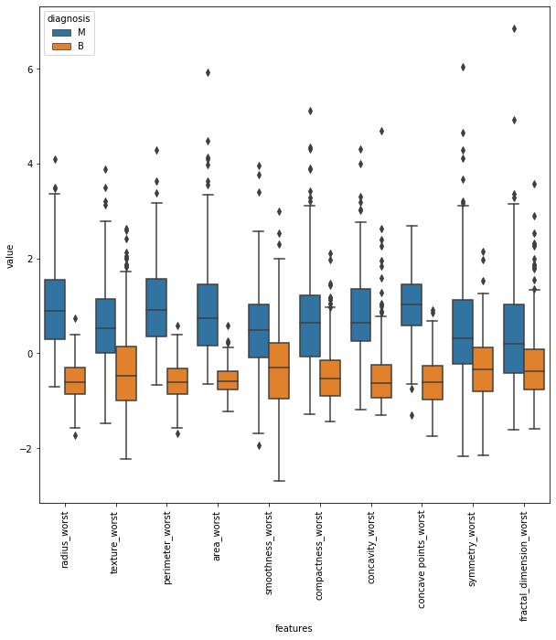

 Also it seems **radius_worst**, **perimeter_worst** and **area_worst** are correlated as it can be seen pair plot. We use these for feature selection.

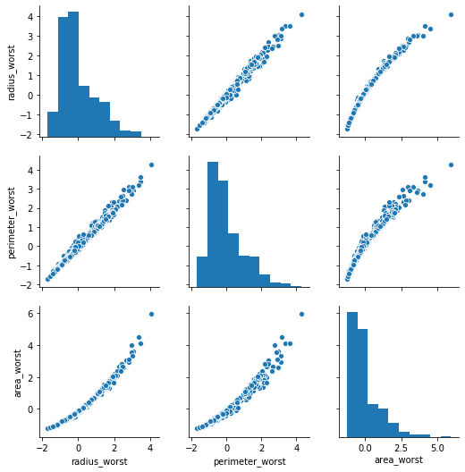

Now in swarm Plot, we plot features in 3 group and each group includes 10 features to observe better.

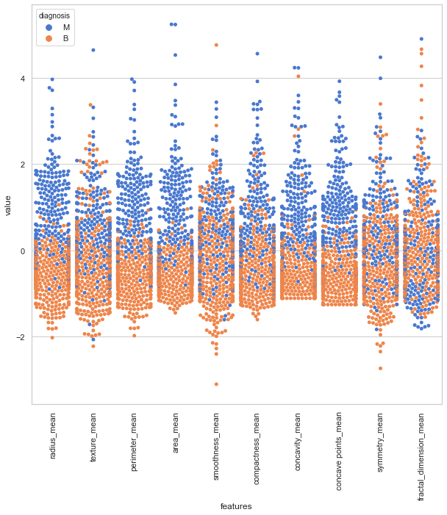

I think **perimeter_mean** and **area_mean** looks like malignant and benign are seprated not totaly but mostly.

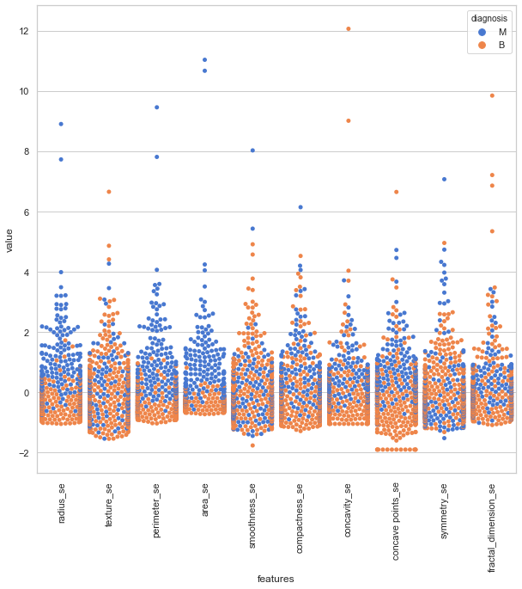

I think **area_se** looks like malignant and benign are seprated not totaly but mostly. Hovewer, **smoothness_se** looks like malignant and benign are mixed so it is hard to classfy while using this feature.

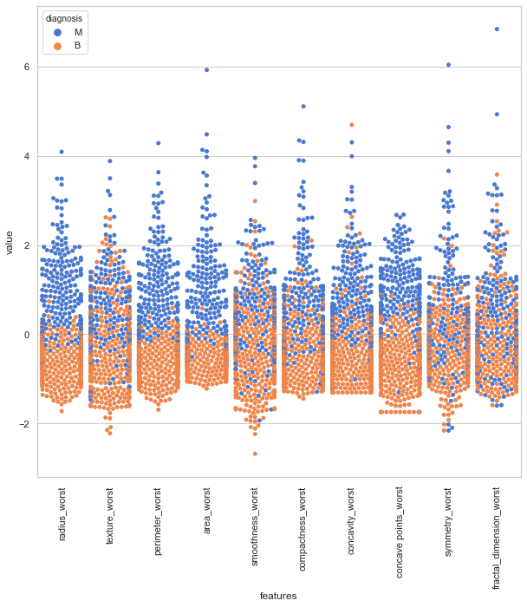

I think area_worst and perimeter_worst looks like malignant and benign are seprated not totaly but mostly. Hovewer, texture_worst looks like malignant and benign are mixed so it is hard to classfy while using this feature.

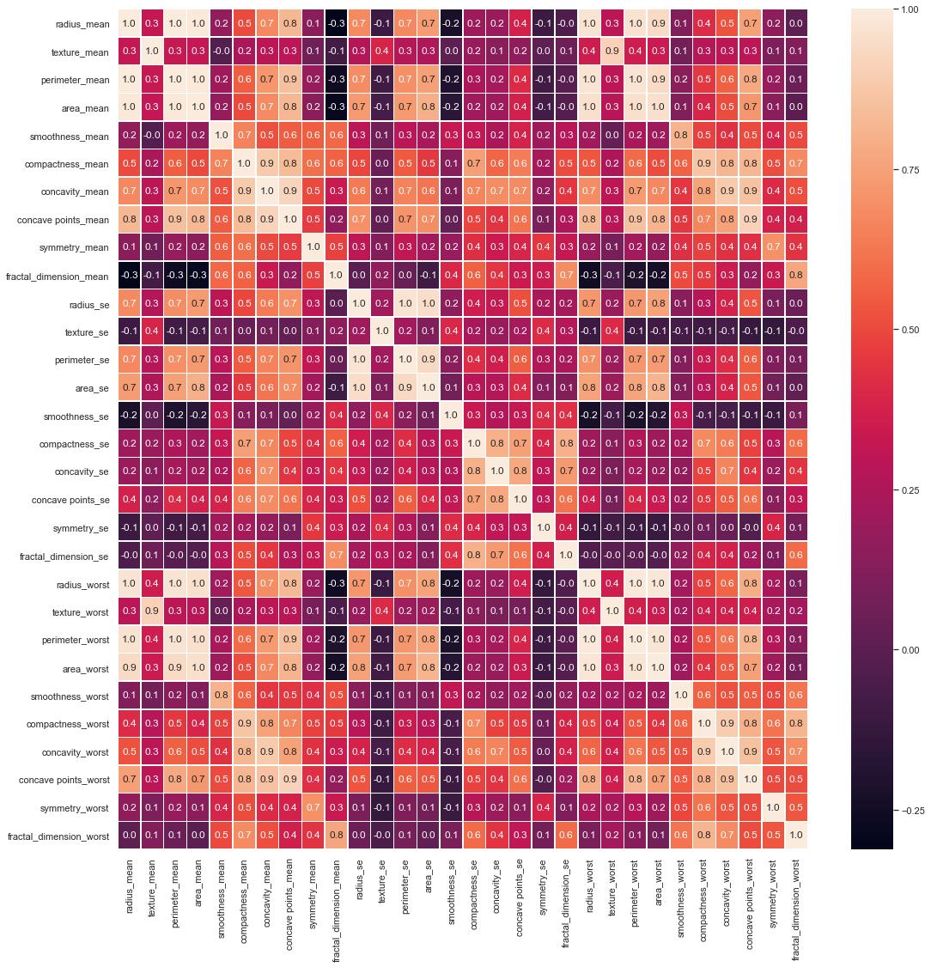

## **EDA – Inferential Statistics**

**In the following EDA, I try to perfom analyze correlation between variable of concavity_worst and concave point_worst.**

# ****Initial observations for Correlation between concavity_worst and concave point_worst****

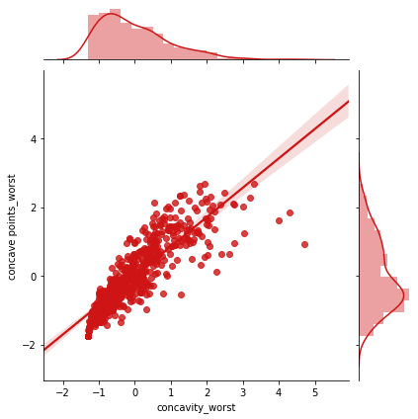

**Pearson correlation coefficient is 0.86, which means there is strong correlation between these two variables.**

# Setup hypothesis test

**Ho : The variable of concavity_worst and concave point_worst are independent**

**Ha : The variable of concavity_worst and concave point_worst are correlated**

**Statistical significance for 𝛼 = 0.01**

**Test Statistic: Pearson correlation coefficient**

To do so, permute the concavity_worst but leave the concave point_worst values fixed. This simulates the hypothesis that they are totally independent of each other. For each permutation, compute the Pearson correlation coefficient and assess how many of your permutation replicates have a Pearson correlation coefficient greater than the observed one.**As p-value less than**α**, we can reject the null hypothesis and accept alternative hypothesis which means that there is a correlation between variable of concavity_worst and concave point_worst**